Serene Plummer
Feburary 18th, 2026
INTERVIEW REPORT
Opening Report
This report examines how surveillance and data-monitoring systems currently operate at the University of North Texas (UNT) and how they relate to concerns about identity-linked pedestrian surveillance. I gathered this information through a structured interview with a UNT IT Student Assistant who works directly with campus technology and security systems.
From this interview, I gained insight into three main areas: that existing monitoring tools are primarily security-driven, that emergency response is used to justify surveillance practices, and that AI-specific privacy protections remain unclear. These findings help clarify where UNT currently stands on surveillance and inform my proposal to restrict identity-linked monitoring practices moving forward.

Background / Methodology
On February 11, 2026, I conducted a 30-minute structured interview with Kyilee Bell, an IT Student Assistant at UNT. Bell works closely with campus technology systems, including network security, device management, and access controls. Her responsibilities include ensuring that university-issued devices are secure, up to date, and protected against malicious downloads.
Because she interacts directly with UNT’s data systems and building access infrastructure, her perspective provides a practical understanding of how monitoring technologies function at an operational level. While Bell is not involved in high-level administrative policy decisions, her daily experience working with these systems offers insight into how surveillance-related tools are actually implemented.
One limitation of this interview is that it represents the perspective of a single IT employee rather than university leadership or decision-makers responsible for adopting new technologies. However, her responses provide useful context for understanding current safeguards and boundaries within UNT’s infrastructure.

Findings

Key Insight #1: Security-Focused Monitoring Rather Than Behavioral Tracking
One of the most important insights from this interview is that UNT’s current monitoring systems appear to focus on cybersecurity and controlled access rather than active pedestrian tracking. Bell explained that much of her work involves keeping systems “up to date” and preventing malicious software from being downloaded onto university-issued devices. The tracking mechanisms on UNT laptops are designed to detect harmful activity, not to monitor personal behavior.
Additionally, access to buildings and restricted rooms is managed through student IDs and key fobs. Access permissions depend on departmental roles, meaning individuals can only enter authorized spaces. While identity is clearly tied to access credentials, there is no indication that movement across campus is actively tracked in real time. At this stage, surveillance seems structured around protection and system integrity rather than behavioral analysis.

Key Insight #2: Emergency Preparedness as Primary Justification
Another major theme that emerged is that safety consistently serves as the primary justification for surveillance technologies. Bell described how monitoring systems assist the police department during investigations and emergencies. For example, panic buttons located at welcome desks allow staff to quickly alert authorities if a situation escalates.
She also shared a personal experience involving vandalism to her vehicle, explaining that surveillance footage could have helped in that situation. This highlights a practical concern: while limiting surveillance strictly to emergencies might better protect privacy, doing so could reduce the university’s ability to respond to non-emergency crimes.
UNT communicates reported incidents through crime alert emails, text messages, and a public crime log. These systems promote transparency about criminal activity, though they do not necessarily explain the full scope of monitoring technologies operating behind the scenes. Overall, safety remains the dominant reasoning behind maintaining surveillance infrastructure.

Key Insight #3: Unclear AI-Specific Privacy Protections
The third key finding involves the lack of clearly defined AI-specific privacy regulations. Bell noted that there “aren’t any strict laws with AI and privacy,” emphasizing that artificial intelligence governance is still developing. She referenced FERPA as a major safeguard protecting student records but did not identify policies specifically addressing advanced analytics or identity-linked surveillance.
Bell expressed concern about invasive technologies such as facial recognition and systems that mine personal data, including addresses, emails, or internal communications. She emphasized that data collection “should be clear and not be sold or used outside of the university” and that sensitive information should remain encrypted within UNT’s systems.
This suggests a potential gap between traditional educational privacy protections and the capabilities of modern AI systems. While FERPA protects academic records, it may not fully address technologies capable of linking behavioral or movement data to individual identities.

Conclusion
This report analyzed current surveillance and monitoring practices at UNT through an interview with an IT Student Assistant. Three major themes emerged: monitoring systems are currently security-focused rather than behaviorally invasive, surveillance is justified primarily through safety and emergency response, and AI-specific privacy protections remain limited or undefined.
These findings directly inform my proposal to restrict identity-linked pedestrian surveillance at UNT. Although current practices appear controlled, the infrastructure linking identity to access already exists. Without clear policy boundaries, more advanced analytics systems could expand beyond their original intent. This interview strengthened my understanding of UNT’s current practices and clarified where stronger ethical AI guidelines may be necessary to protect student privacy while maintaining campus safety.

References
Bell, K. (2026, February 11). Personal interview.

Serene Plummer
February 19, 2026
SECONDARY RESEARCH REPORT
Opening Statement
This report examines patterns in secondary research about high-tech surveillance in public institutions, with a focus on how these systems affect universities. The research specifically considers technologies that track movement patterns, analyze behavioral data, and link that information to individual identities. After reviewing five secondary sources, three main patterns emerged: surveillance technologies are expanding faster than oversight policies; these systems disproportionately impact marginalized communities and discourage open expression; and partnerships between institutions and private technology companies make transparency and accountability more complicated. Together, these findings suggest that if universities such as the University of North Texas adopt identity-linked surveillance systems, they must carefully consider the ethical, privacy, and civil liberties risks before implementation.
Background / Methodology
The research for this report included a mix of nonprofit civil liberties organizations, investigative journalism, and peer-reviewed academic scholarship. Sources were selected from established organizations such as the American Civil Liberties Union, the Electronic Frontier Foundation, and major publications like The Guardian and Bloomberg, along with one scholarly journal article. This range of sources allowed for both current reporting on surveillance practices and deeper academic analysis of how these technologies function and impact institutions. The research specifically focused on systems capable of tracking movement patterns, analyzing behavioral data, and linking that data to individual identities.
One limitation of the research is that several sources focus more heavily on K–12 schools or broader government surveillance rather than exclusively on universities. However, many of the same technologies, including facial recognition, behavioral analytics platforms, and identity-linked data systems, are used across public institutions. Because of this overlap, the concerns discussed in these sources are still directly relevant to higher education and to the University of North Texas specifically. Although not every source addresses UNT by name, the patterns identified clearly apply to universities considering advanced analytics platforms that track and identify individuals on campus.
Findings
1. Surveillance Technologies Are Expanding Faster Than Policy Oversight
One consistent theme across the sources is that surveillance tools are often adopted before strong policies are created to regulate them. The ACLU argues that public video surveillance systems are frequently justified as crime prevention strategies, even though there is limited evidence that they significantly reduce crime. Instead, they create long-term monitoring infrastructures that can later be expanded or repurposed without clear public consent.
Similarly, reporting from The Guardian explains how schools are increasingly adopting monitoring software that tracks students' online activity, location data, and communications. These technologies are marketed as safety tools, but there is often little transparency about how data is stored, who can access it, or how long it is retained.
The Electronic Frontier Foundation also highlights how campus police departments use advanced tools such as social media monitoring and data analytics platforms without clearly informing students. In many cases, institutions adopt these technologies reactively in response to safety concerns rather than proactively establishing clear guidelines. Across the sources, the pattern is clear: surveillance capabilities are growing rapidly, while oversight mechanisms struggle to keep up.
2. Surveillance Disproportionately Impacts Marginalized Communities and Chills Expression
Another major pattern is that surveillance does not affect all groups equally. Multiple sources emphasize that high-tech monitoring tools often place heavier scrutiny on marginalized communities. The ACLU explains that surveillance historically targets communities of color, immigrants, and activists, and these same patterns now appear in digital surveillance systems. Technologies like facial recognition and predictive analytics are often described as objective, but they rely on biased data that can produce unequal outcomes.
The scholarly article further discusses how surveillance creates what is known as a “chilling effect.” When individuals know they are being monitored, they may change their behavior, even if they are not doing anything wrong. In a university setting, this is especially concerning. College campuses are meant to encourage debate, activism, and critical thinking. If students believe their social media posts, protests, or academic research could be monitored, they may hesitate to fully express their opinions.
The EFF also documents cases where campus police monitored student activism using advanced surveillance tools. Even when institutions frame these technologies as safety measures, their presence shifts the power dynamic between students and administration. Across the sources, surveillance is not portrayed as neutral technology. Instead, it interacts with existing social inequalities and can reinforce them, leading certain groups to feel more watched and less protected.
3. Public-Private Partnerships Complicate Transparency and Accountability
The final pattern involves the relationship between public institutions and private technology companies. Investigative reporting from Bloomberg discusses how companies like Palantir provide powerful data analytics tools to government agencies and institutions. These systems often involve proprietary software, meaning the public cannot easily evaluate how they function or how data is processed.
When universities partner with private surveillance companies, questions arise about data ownership, retention policies, and third-party access. Civil liberties organizations argue that outsourcing surveillance to private firms does not remove constitutional concerns. Instead, it can make accountability more difficult because responsibility becomes distributed across multiple entities.
The Guardian also highlights how school surveillance vendors market their products as necessary for safety while retaining broad access to student data. Contracts may lack clarity about long-term data use, creating uncertainty about privacy protections. Overall, the pattern shows that surveillance expansion is not only driven by institutional demand but also by private companies that actively promote high-tech monitoring solutions. This dynamic complicates transparency and raises additional ethical concerns.
Conclusion
This report analyzed five secondary sources on the expansion of high-tech surveillance in public institutions and its impact on higher education. Three patterns emerged: surveillance technologies are expanding faster than oversight policies; these systems disproportionately affect marginalized communities and discourage open expression; and partnerships with private technology companies weaken transparency and accountability. These findings directly relate to the pressure facing the University of North Texas to adopt identity-linked analytics platforms.
The research shows that once implemented, surveillance systems often expand beyond their original purpose and operate with limited oversight. Even when framed as safety tools, platforms like Palantir Technologies Inc. can normalize constant monitoring and increase the risk of misuse of sensitive data. Overall, the evidence supports the concern that UNT must prioritize privacy and clear limitations before adopting identity-linked surveillance technologies.

Works Cited
American Civil Liberties Union. What’s Wrong with Public Video Surveillance? ACLU, www.aclu.org/documents/whats-wrong-public-video-surveillance.
American Civil Liberties Union of Northern California. Fighting High-Tech Government Surveillance. www.aclunorcal.org/fighting-high-tech-government-surveillance/.
Electronic Frontier Foundation. Scholars Under Surveillance: How Campus Police Use High-Tech Tools to Spy on Students. www.eff.org/deeplinks/2021/03/scholars-under-surveillance-how-campus-police-use-high-tech-spy-students.
The Guardian. “School Surveillance Tech Raises Privacy Concerns, ACLU Report Finds.” 4 Oct. 2023, www.theguardian.com/technology/2023/oct/04/school-surveillance-tech-aclu-report.
Winston, Ali. “The Data-Mining Company That’s Building a Surveillance State.” Bloomberg Businessweek, 2018, www.bloomberg.com/features/2018-palantir-peter-thiel/.

Serene Plummer
March 8, 2026

The Qualtrics eSurvey Report

Opening Statement
This report investigates UNT student attitudes toward identity-linked surveillance (systems linking movement data to student IDs or facial recognition). As universities adopt advanced data analytics, concerns over privacy, transparency, and ethics are rising.
Qualtrics eSurvey responses revealed three patterns: students are largely unfamiliar with the technology; most respondents are uncomfortable with their movements being tracked and linked to their identity; and students strongly support better transparency and oversight, including limiting surveillance to emergencies and requiring notification. These findings indicate widespread student concern about privacy and the use of surveillance on campus.

Background / Methodology
Data was collected via a Qualtrics eSurvey distributed online and through peer networks to students across different majors and class standings. The survey measured awareness of surveillance technologies, attitudes toward privacy and campus safety, and opinions on transparency and policy safeguards.
A total of 22 responses were collected, mainly from junior (9) and Computer Science (12) students. Other majors included engineering, cybersecurity, accounting, and IT.
Survey limitations include the small sample size, which limits generalizability to the entire UNT student population. Additionally, most respondents lived off campus (21 of 22), potentially influencing their views on campus surveillance. Despite these limitations, the responses offer valuable insight into student perspectives on privacy and surveillance.

Findings

Limited Student Awareness of Identity-Linked Surveillance
One clear finding from the survey is that many students are not very familiar with identity-linked surveillance technologies. When asked whether they were familiar with the concept of surveillance systems capable of linking movement data to individual identities, most respondents reported little or no familiarity.
Specifically, 7 respondents reported being “not familiar at all,” and 6 reported being only “slightly familiar.” Only 5 respondents indicated they were very familiar with the concept.
This lack of awareness suggests that many students may not fully understand the capabilities of modern surveillance technologies or how these systems could potentially be used on college campuses. Even so, students still expressed strong opinions about privacy concerns once the idea was explained in the survey.
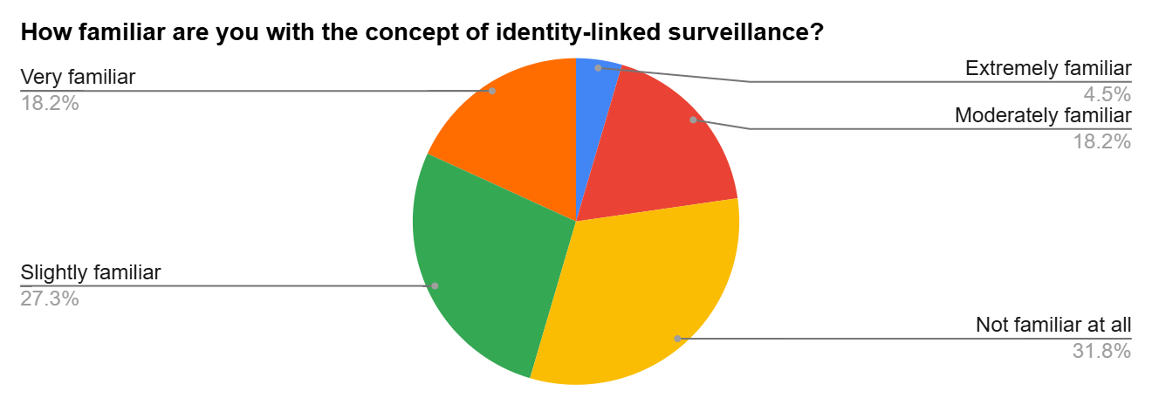
Figure 1: Familiarity with Identity-Linked Surveillance

2. Students Express Strong Discomfort with Identity-Linked Surveillance
A second major pattern in the survey results is that students are generally uncomfortable with the idea of identity-linked surveillance being used on campus.
When asked about their comfort level with identity-linked pedestrian surveillance at UNT, 19 out of the 22 respondents expressed discomfort. Out of these, 10 reported being extremely uncomfortable, and 9 reported being somewhat uncomfortable. Only 3 respondents reported feeling neutral, and none reported feeling comfortable with the idea.
These responses suggest that many students see identity-linked surveillance as a possible invasion of privacy. Open-ended responses also supported this concern, with students mentioning fears of “privacy invasion,” “being constantly watched,” and uncertainty about how their personal data might be used or accessed. Some respondents also raised concerns about possible data misuse or security breaches.
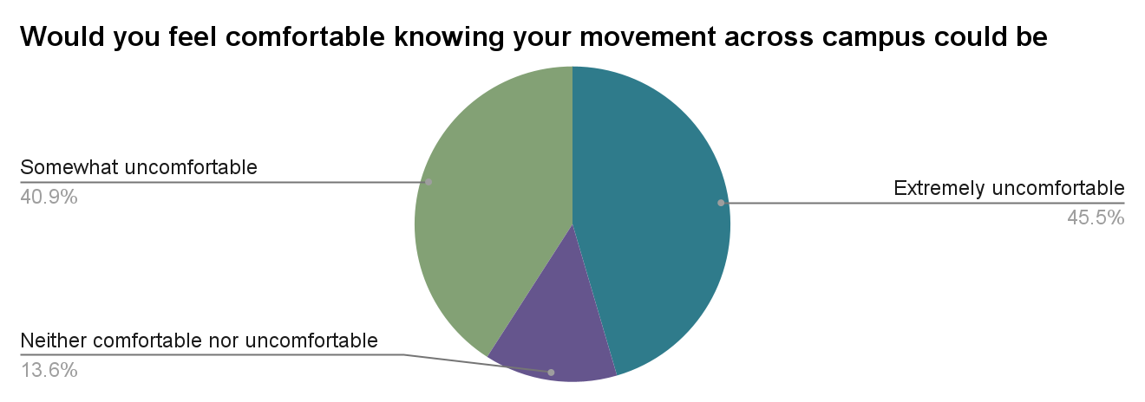
Figure 2: Comfort Level with Identity-Linked Surveillance

3. Students Strongly Support Transparency and Emergency-Only Use
The third major finding is that students strongly support clear policies limiting how surveillance technologies are used on campus. Several survey questions showed strong support for transparency, oversight, and restricting surveillance to emergencies.
For example:
13 respondents said surveillance should be limited strictly to emergencies
12 respondents said pedestrian data should remain anonymous by default
18 respondents said students should be notified when surveillance technology is being used
12 respondents supported regular independent audits of AI-based surveillance systems
These results suggest that students are not completely opposed to security technologies, but they want strong safeguards in place to protect their privacy. Many respondents emphasized the importance of transparency, including clear explanations of what data is being collected, who has access to it, and how it is stored.
Open-ended responses also reinforced this point. Several students said they would feel more comfortable if surveillance were limited to safety situations, if data collection practices were clearly explained, and if human oversight were involved.
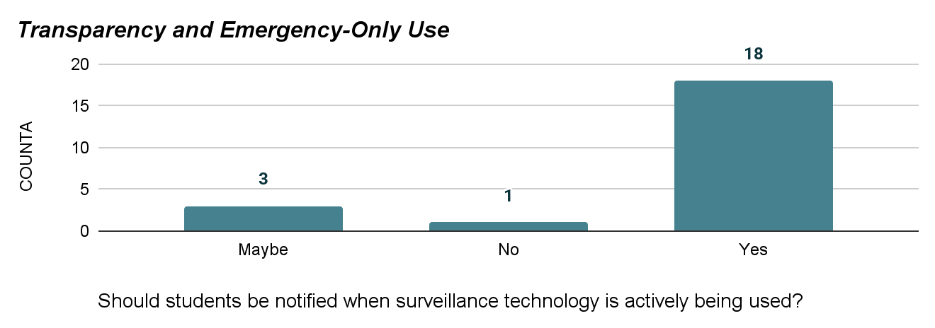
Figure 3: Support for Notification When Surveillance Is Used

Conclusion
An eSurvey at the University of North Texas examined student attitudes toward identity-linked surveillance. Findings showed students are often unfamiliar with these technologies but largely uncomfortable with systems that track and link movement to identity. Students strongly supported transparency and safeguards, including notification, independent oversight, and emergency-only use. Overall, while recognizing the need for campus safety, students are concerned about privacy risks. The results advocate for clear policies prioritizing transparency, data protection, and ethical tech use, which could guide future implementation discussions and enhance student trust.

References
Plummer, Serene. (2026). Student Attitudes Toward Identity-Linked Surveillance at the University of North Texas. Qualtrics eSurvey.

